COURSE CODE: CSA1122

COURSE NAME: Object Oriented Analysis and Design

**1. Develop a system using UML for Passport Management System, It should verify the passport details of the applicant by the central computer. The details regarding the passport will be provided to the central computer and the computer will verify the details of the applicant and provide approval to the office. Then the passport will issue from the office to the applicant.**

**Aim:** To design a UML diagram for passport management system using umbrello software and implement the program in java. **Software used:** Umbrello **Use case diagram:**

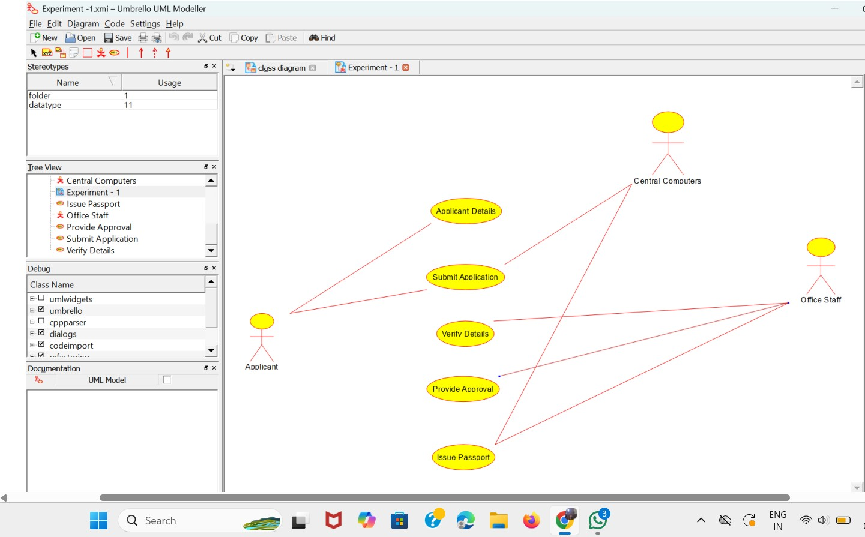

**Result:** thus the project of implementing the passport management system is created and the implementation of program in java is successfully done.

**Develop a system using UML for implementing the Book Bank process. It should verify the details of the student by the central computer. The details regarding the student will be provided to the central computer through the administrator in the book bank and the computer will verify the details of the student and provide approval to the office. Then the books that are needed by the student will issue from the office to him.**

**Aim:** To design a UML diagram for passport Book Bank process using umbrello software and implement the program in java. **Software used:** Umbrello **Daigram:**

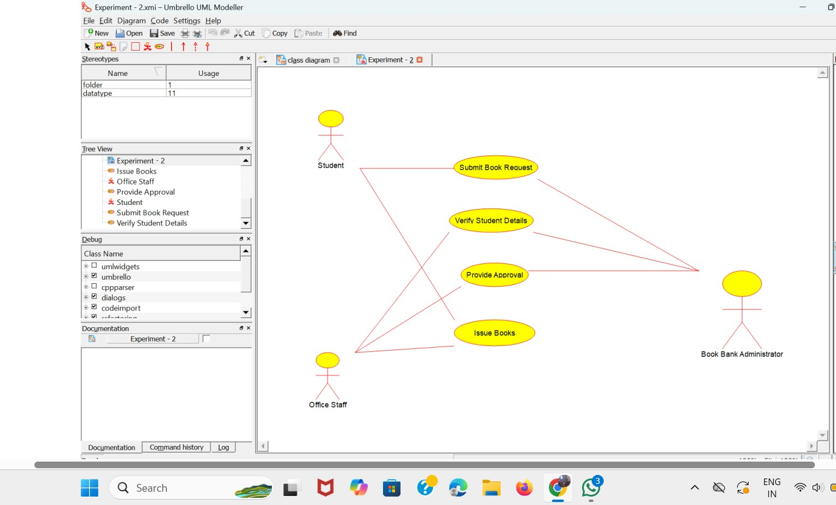

**Result:** thus the project of implementing the passport management system is created and the implementation of program in java is successfully done.

**Develop a system using UML for implementing the Exam Registration Portal. It should verify the details of the candidate by the central computer. The details regarding the candidate will be provided to the central computer through the administrator and the computer will verify the details of the candidate and provide approval. Then the hall ticket will be issued from the office to the candidate.**

**Aim:** To design a UML diagram for Exam Registration portal using umbrello software and implement the program in java. **Software used:** Umbrello **Daigram:**

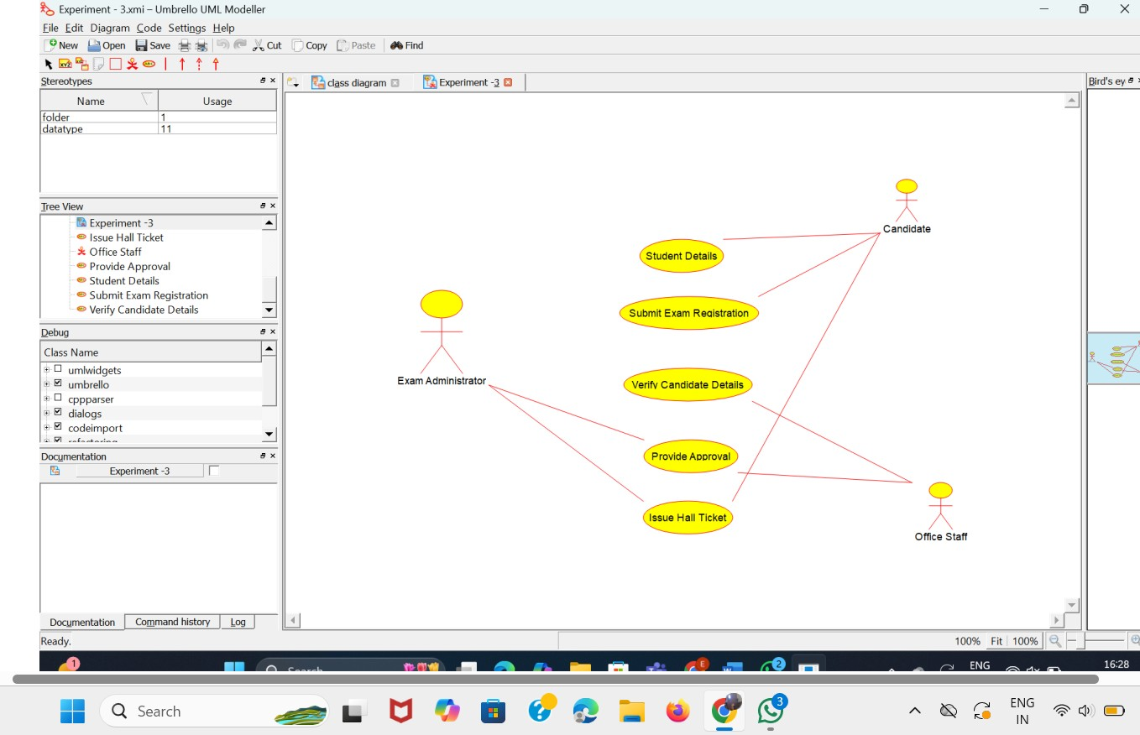

**Result:** thus the project of implementing the Exam Registration Portal is created and the implementation of program in java is successfully done.

**Develop a system using UML for implementing Stock Maintenance System. In this system, the customer can place orders and purchase items with the aid of the stock dealer and central stock system. These orders are verified and the items are delivered to the customer. Then the stock details are to be updated accordingly Aim:** To design a UML diagram for Stock Maintenance System using umbrello software and implement the program in java.  **Software used:** Umbrello  **Daigram:**

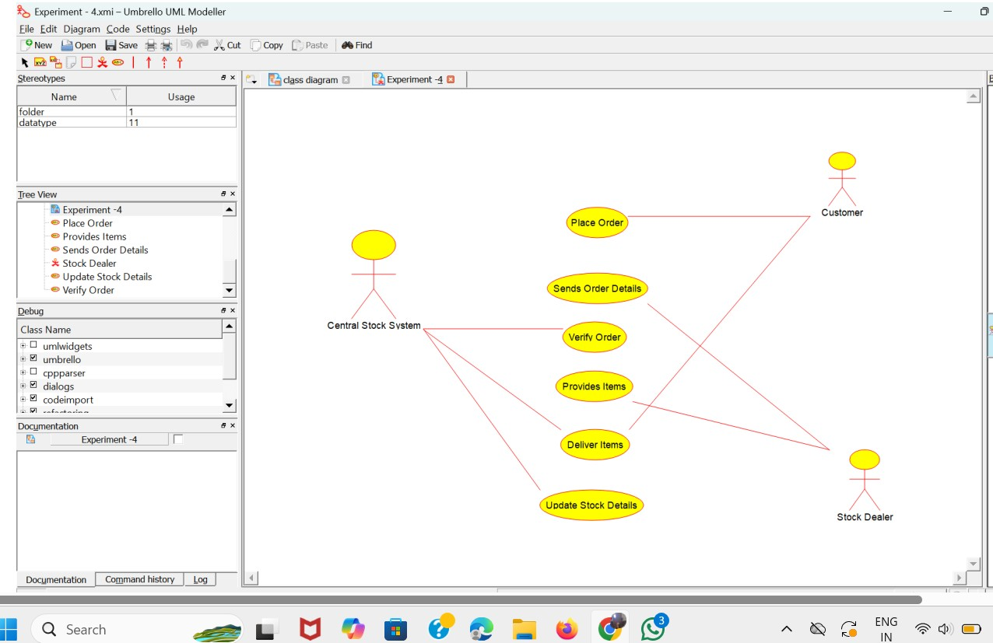

**Result:** thus the project of implementing the stock maintanence system is created and the implementation of program in java is successfully done.

**Develop a system using UML for implementing Online Course Reservation System. This system is organized by the central management system. The student first browses and selects the desired course of their choice. The university then checks the availability of the seat if it is available the student is enrolled for the course.**

**Aim:** To design a UML diagram for Online Course Reservation using umbrello software and implement the program in java.  **Software used:** Umbrello  **Daigram:**

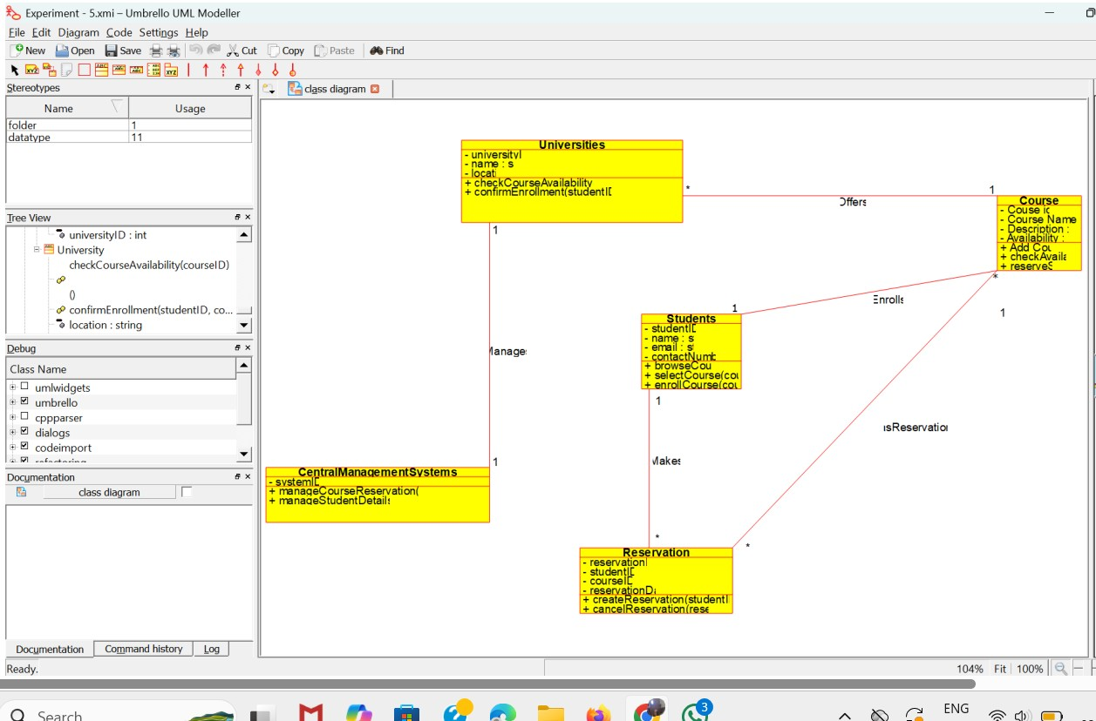

**Result:** thus the project of implementing the Online Course Reservation is created and the implementation of program in java is successfully done.

**Experiment 06: Railway reservation System**

**AIM:** To draw a class daigram for railway resevation system **sofware requirments:**umbrello uml model

**clas diagram:**

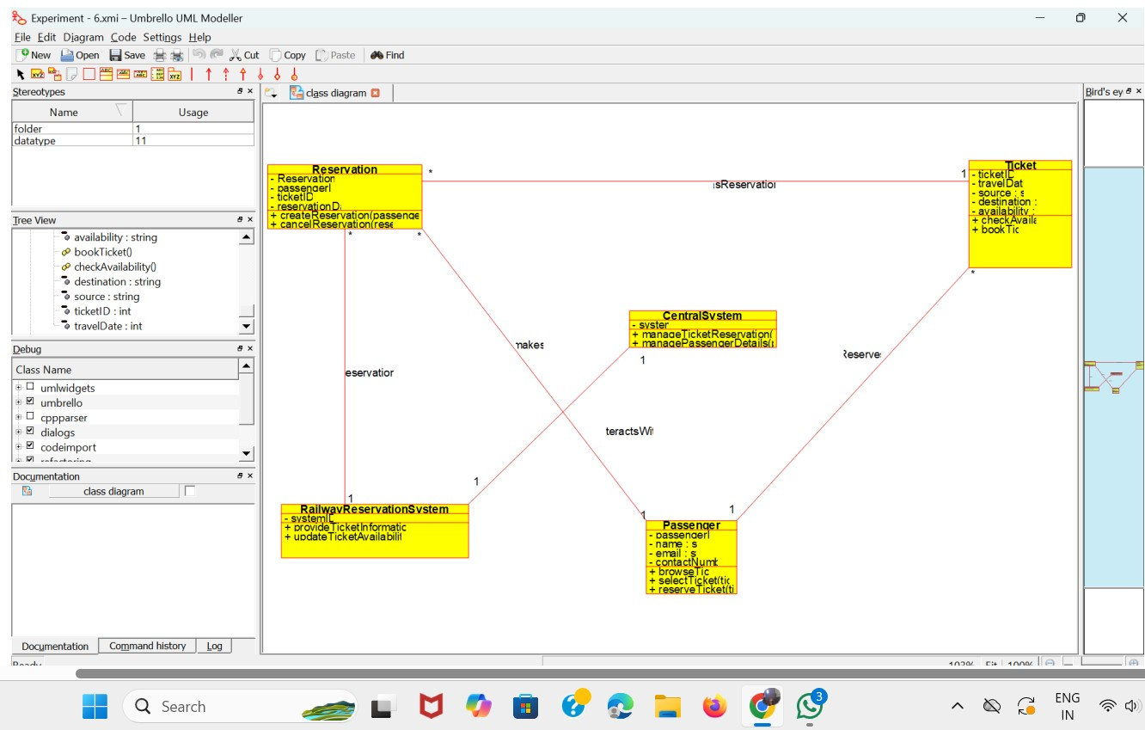

**Result:**Thus the classdaigram for railway reservation system excuted and designed successfully.

**Experiment 07: Credit Card Proccessing System**

**AIM:** To draw a class daigram for credit Card proccessing system **sofware requirments:**umbrello uml model

**class diagram:**

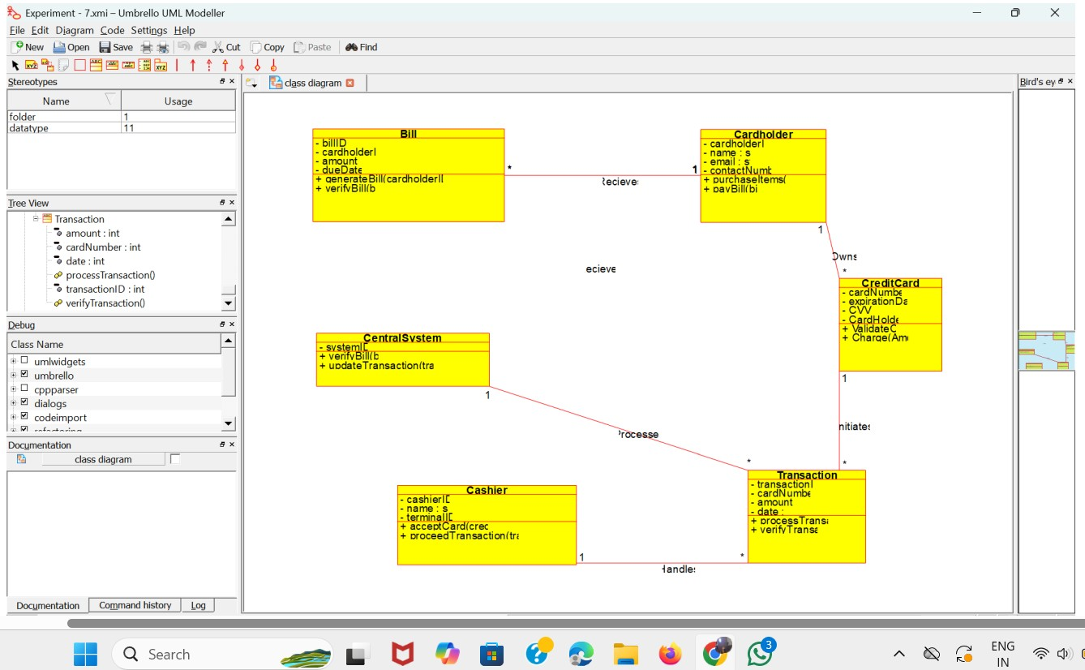

**Result:**Thus the class daigram for credit Card proccessing systemsystem excuted and designed successfully.

**Experiment 08:Software personal Management System.**

**AIM:** To draw a class daigram for Software personal

Management System.

**sofware requirments:**umbrello uml model **class diagram:**

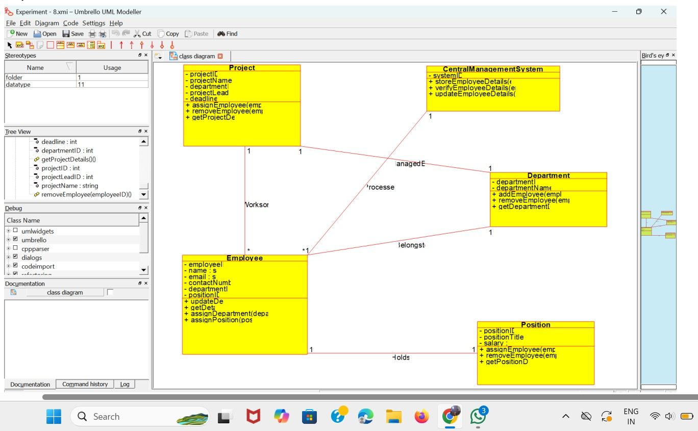

**Result:**Thus the class daigram for Software personal management system system excuted and designed successfully.

**Experiment 09:** **E-book managmenet System**

**AIM:**To draw a Sequence daigarm E-book managmenet System **sofware requirments:**umbrello uml model **Sequence diagram:**

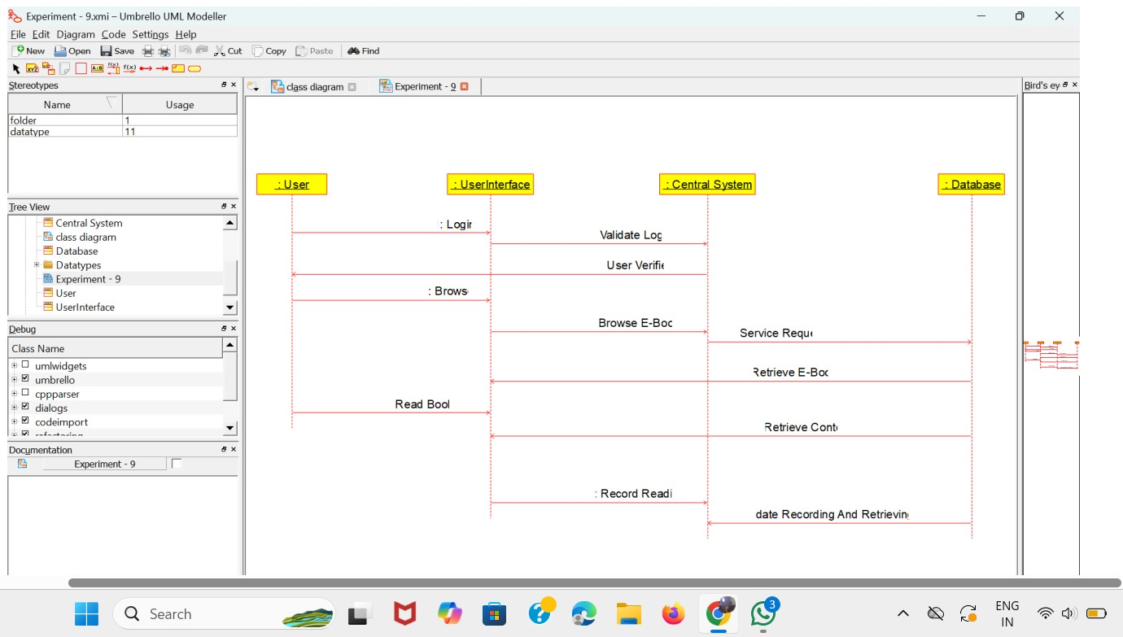

**Result:**Thus the sequence daigarm E-book managmenet System excuted and designed successfully.

**Experiment 10:Recuritment System**

**AIM:**To draw a Sequence daigram for recuirtment system.

**sofware requirments:**umbrello uml model

**Sequence diagram**



**Result:**Thus the Sequence daigram for recuirtment system.excuted and designed successfully.

# EXNO:11 CONFERENCE MANAGEMENT SYSTEM

**AIM:**

To draw the class diagram for Conference management system

**SOFTWARE REQUIREMENTS**: Umbrello

**OUTPUT:**



**Result:** Thus draw the class diagram for Conference management system has been designed, executed and output is verified.

# EXNO:12 FOREIGN TRADING SYSTEM

**AIM**: To draw the class diagrams for foreign trading system.

**SOFTWARE REQUIREMENTS**: Umbrello

**OUTPUT:**



**RESULT:** Thus the class diagram for foreign trading system has been designed, executed and output is verified.

# EX.NO 13 BPO MANAGEMENT SYSTEM

**AIM:** To draw the Class diagram for the BPO Management System.

**SOFTWARE REQUIREMENTS**: Umbrello

**OUTPUT:**



**RESULT:** The Class diagram for the BPO Management system has been designed, executed and output is verified

**EX.NO 14 E-COMMERCE REGISTRATION SYSTEM**

**AIM:** To draw the Sequence diagram for the e-commerce registration system

**SOFTWARE REQUIREMENTS**: Umbrello

**Output:**



**RESULT:** The Sequence diagram for the e-commerce registration system has been designed, executed and output is verified

**EX.NO 15 BLOOD BANK REGISTRATION SYSTEM**

**AIM:** To draw the Sequence diagram for the bank registration system.

**SOFTWARE REQUIREMENTS**: Umbrello

**OUTPUT:**

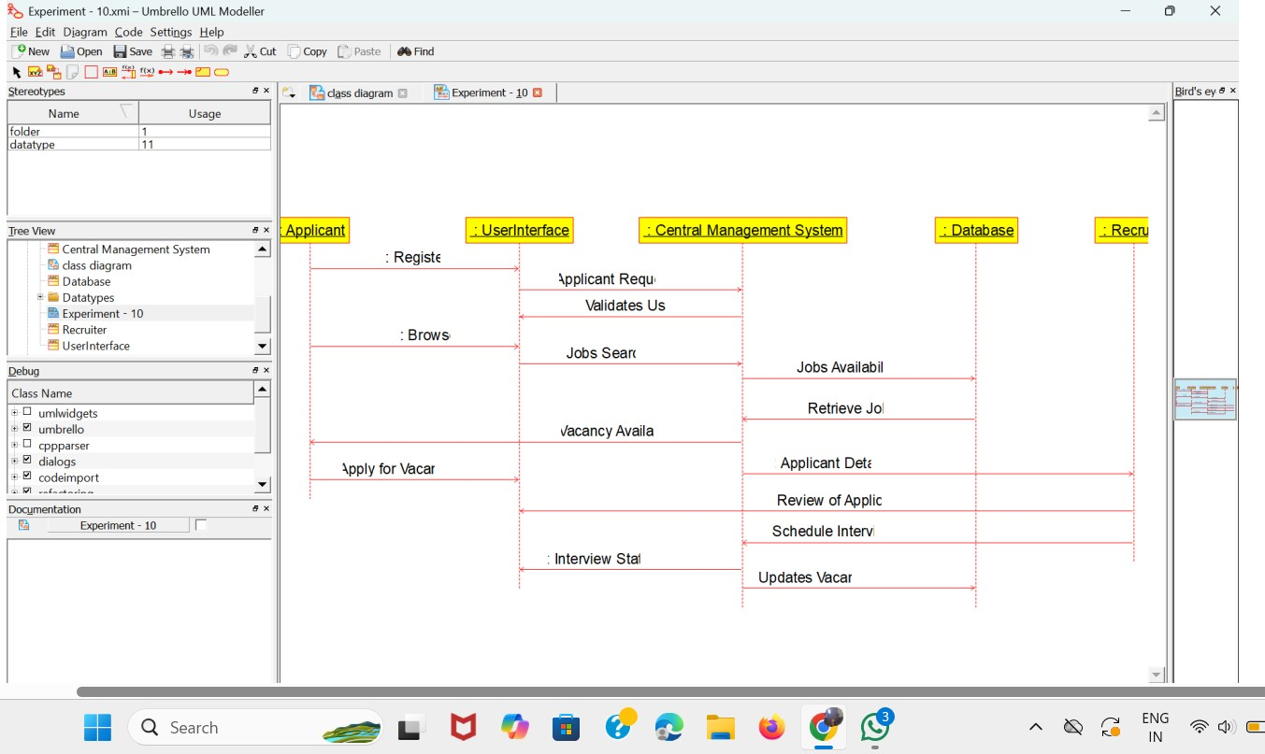

**RESULT:** The Sequence diagram for the blood bank registration system system has been designed, executed and output is verified

**Experiment 16:**

Develop a system using UML for Online Internship Registration System. It should verify the details of the candidate by the central computer. The details regarding the candidate will be provided to the central computer through the administrator and the computer will verify the details of the candidate and provide approval. Then the internship letter will be issued from the company to the candidate.

AIM:

Develop a system using UML for Online Internship Registration System.

SOFTWARE REQUIREMENTS: Umbrello software

CLASS DIAGRAM:

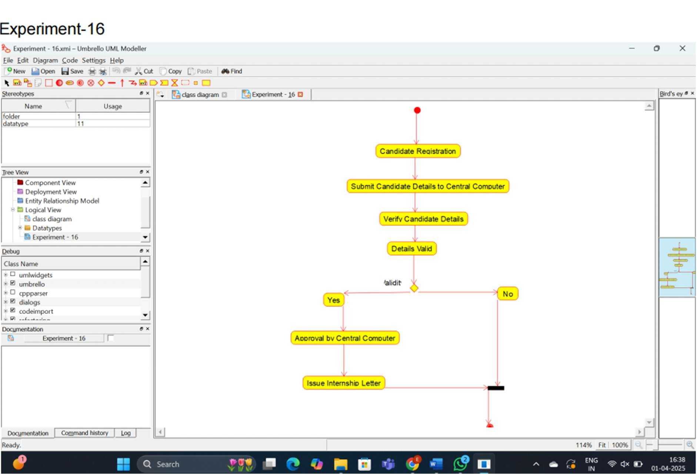

RESULT:

Thus, to design UML diagram for Online Internship Registration System. using umrbello software.

Experiment 17:

Develop a system using UML for Vehicle Registration Number Registering System. The owner should apply with the documents and pay the fee, once the documents had been accepted and the vehicle is verified. Then the document for registration is issued by the system.

AIM:

Develop a system using UML for Vehicle Registration Number Registering System.

SOFTWARE REQUIREMENTS:

Umbrello software

CLASS DIAGRAM:

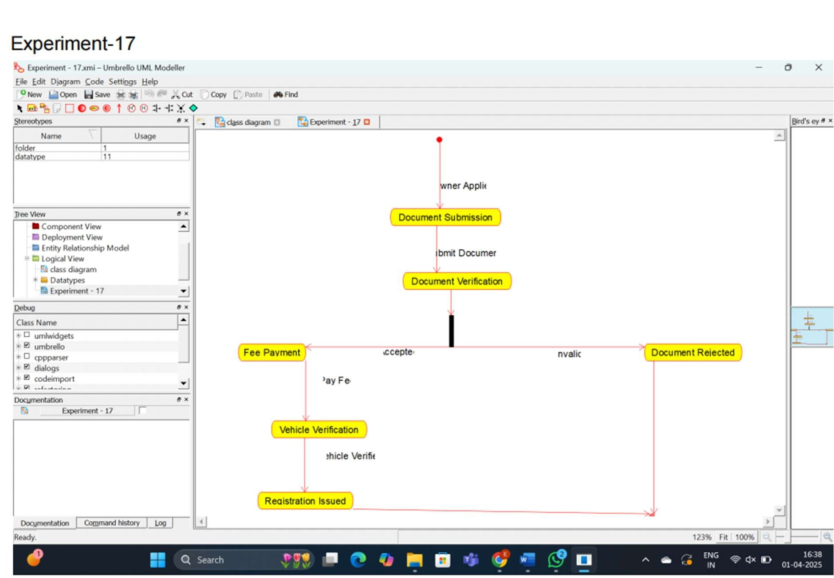

RESULT:

Thus, to design UML diagram forVehicle Registration Number Registering System.

using umrbello software.

Experiment 18:

Develop a system using UML for Food Order System. In this system, the customer can place orders and purchase items with the aid of the dealer and central food system.

These orders are verified and the items are delivered to the customer.

AIM:

Develop a system using UML for Food Order System.

SOFTWARE REQUIREMENTS:

Umbrello software

CLASS DIAGRAM:

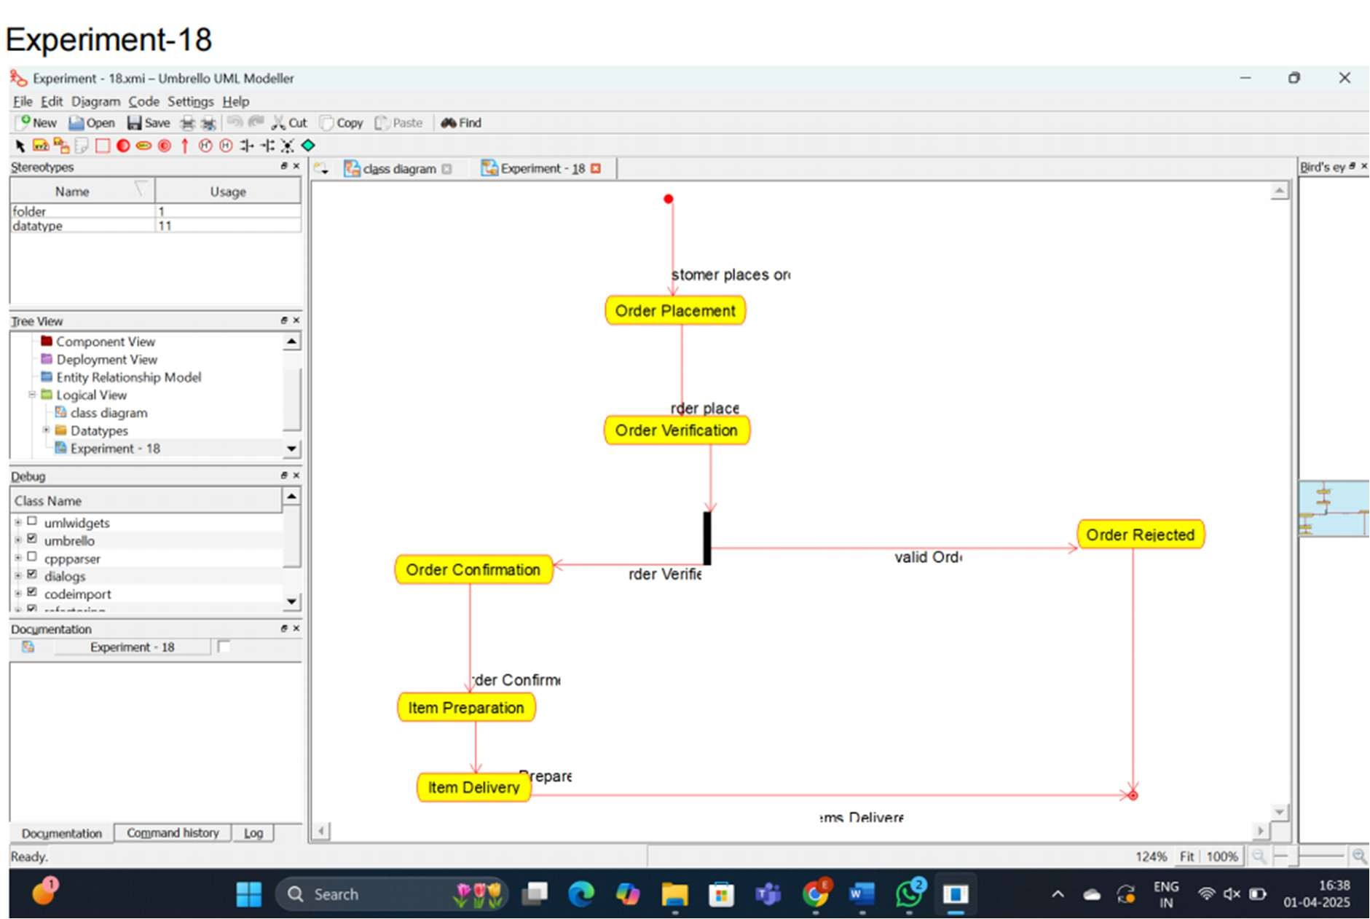

RESULT:

Thus, to design UML diagram for Food Order System. using umrbello software.

Experiment 19:

Develop a system using UML for Home Services System. HACS is a system controlled by a remote system such as a mobile phone and coordinates home appliances. The document furnishes the detailed design with all the UML diagrams. It encompasses CRC cards, Use Case Diagrams, Sequence Diagrams, and Class Diagrams for home appliance control systems (HACS).

AIM:

Develop a system using UML for Home Services System.

SOFTWARE REQUIREMENTS:

Umbrello software

CLASS DIAGRAM:

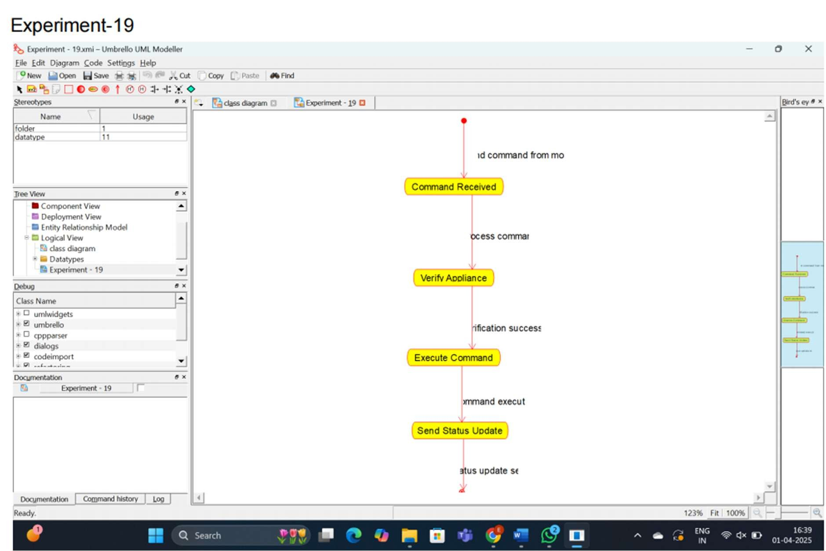

RESULT:

Thus, to design UML diagram for Home Services System. using umrbello software.

Experiment 20:

Develop a system using UML for Library Management System. It should verify the details of the reader by the central computer. The details regarding the reader will be provided to the central computer through the administrator in the library and the computer will verify the details of the reader and provide approval to the office. Then the books that are needed by the reader will issue from the library to him.

AIM:

Develop a system using UML for Library Management System.

SOFTWARE REQUIREMENTS:

Umbrello software

CLASS DIAGRAM:

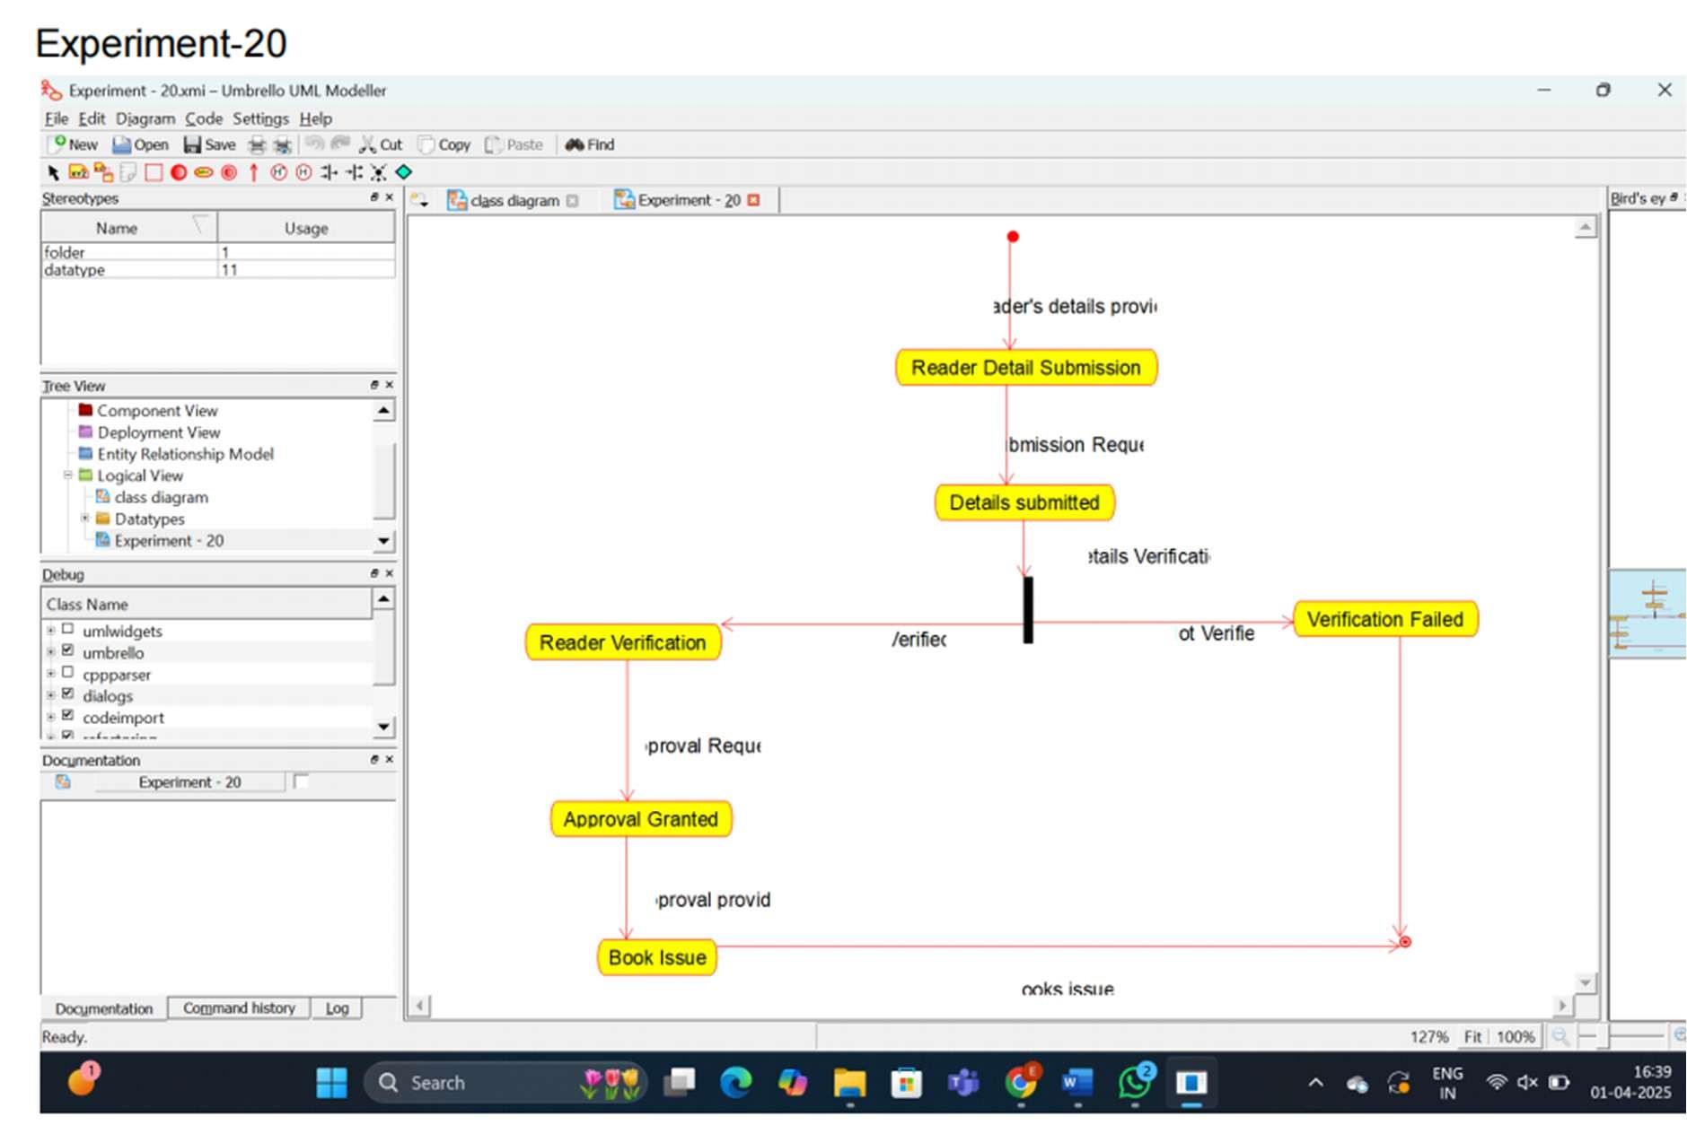

RESULT:

Thus, to design UML diagram for Library Management System. using umrbello software.

**21. Develop a system using UML for Hospital Management System. The central system should manage patients’ and doctors’ appointments and case details. Also, include medical prescriptions and consultation fee details.**

**AIM :** TO draw the class diagram for Hospital Management System

**Software Requirement :** Umbrello

**Class Diagram :**

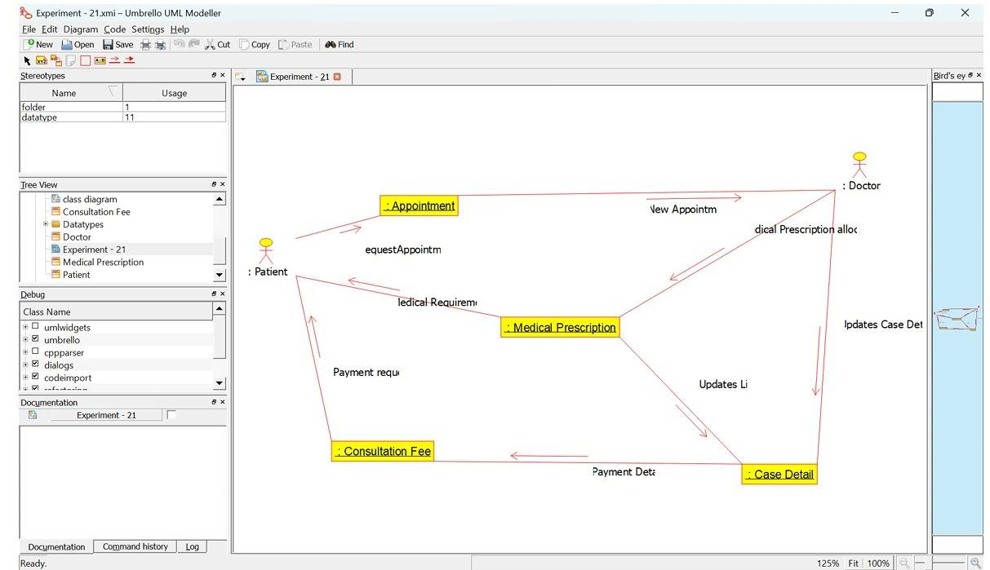

**Result :** Thus the diagram for Hospital Management System has been designed executed and output verified

**.Develop Insurance Processing System.**

**The admin can create a category and sub-category, under which a new policy can be added. The user can view and buy the required policies.**

**The system is managed by the Insurance Management System.**

**AIM :** TO draw the state diagram for Online Insurance Processing System.

**Software Requirement :** Umbrello

**State diagram :**

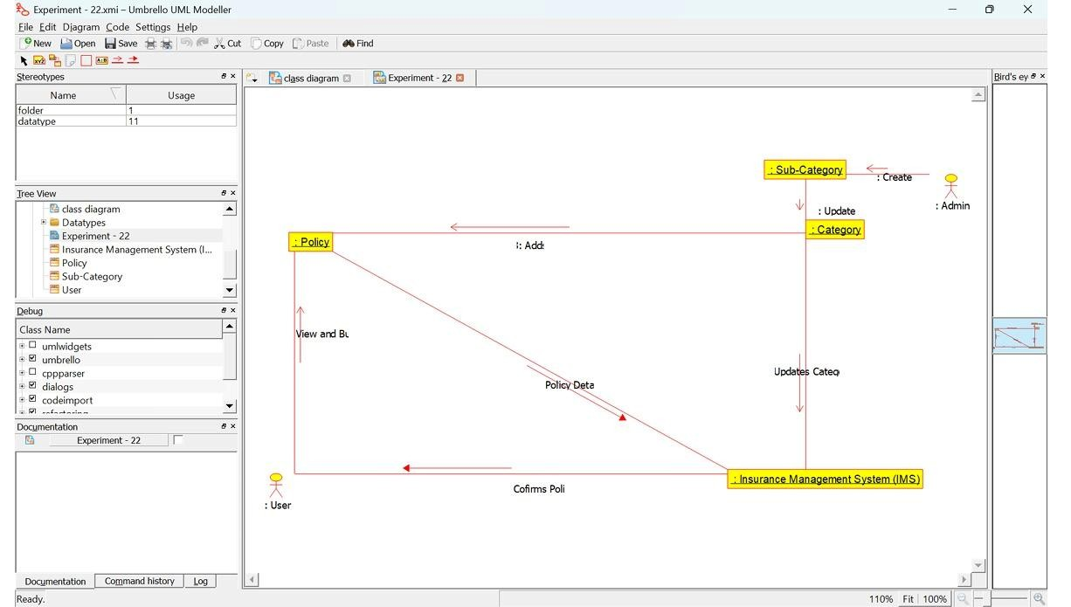

**Result :** Thus the diagram for Online Insurance Processing System. has been designed executed and output verified

**.Develop Shopping System. This system should represent the shopping system as well as its primary users, and roles. The logs of the transactions should be carried out for the shopping. The cart should be maintained before the purchase transaction.**

**AIM :** TO draw the state diagram for the Online Shopping System.

**Software Requirement :** Umbrello

**State diagram :**

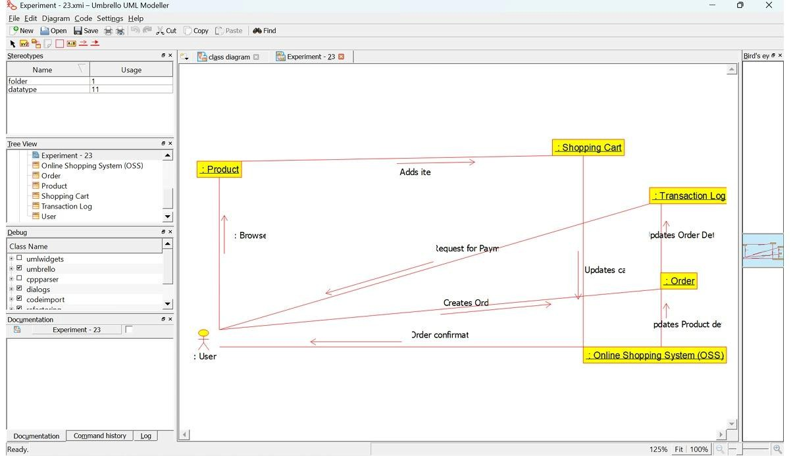

**Result :** Thus the diagram for Online Shopping System. has been designed executed and output verified

**.Develop Stock Market System. This**

**System facilitates its users to trade (i.e. buying and selling) stocks online. It allows clients to keep track of and execute their transactions of the different stocks in their portfolios. The central system should keep track of all the users, who interact with the system.**

**AIM :** TO draw the state diagram for the OnlineStock Market System.

**Software Requirement :** Umbrello

**State diagram :**

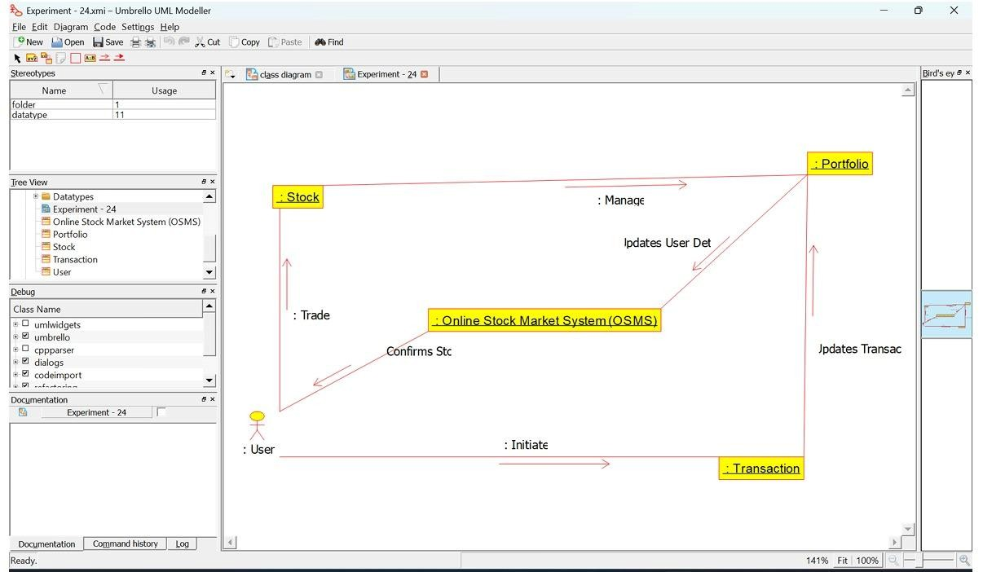

**Result :** Thus the diagram for OnlineStock Market System has been designed executed and output verified

**.Develop Voting System. Registration of the new citizen and update can be done in the system. The process of initiating the polling. The voting was done from the citizen’s end and the result publishing should be maintained by the admin.**

**AIM :** TO draw the state diagram for the Online Voting System

**Software Requirement :** Umbrello

**State diagram :**

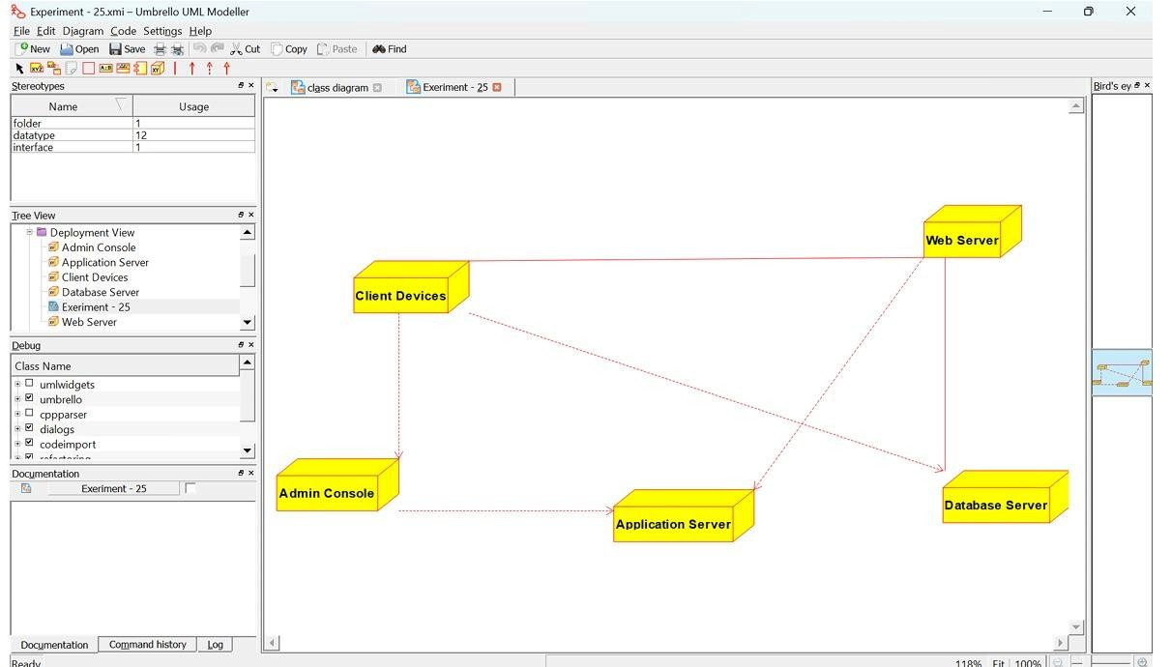

**Result :** Thus the diagram for Online Voting System has been designed executed and output verified

# EXPERIMENT-26:Jewellery shop Management System

To draw the deployment diagram for the Jewellery Management System

**SOFTWARE REQUIREMENTS:**

Umbrello UML modeller

## DEPLOYMENT DIAGRAM

A deployment diagram in the unified modeling language serves to model the physical deployment of artifacts on deployment targets. Deployment diagrams show "the allocation of artifacts to nodes according to the Deployments defined between them. It is represented by 3- dimentional box. Dependencies are represented by communication association.

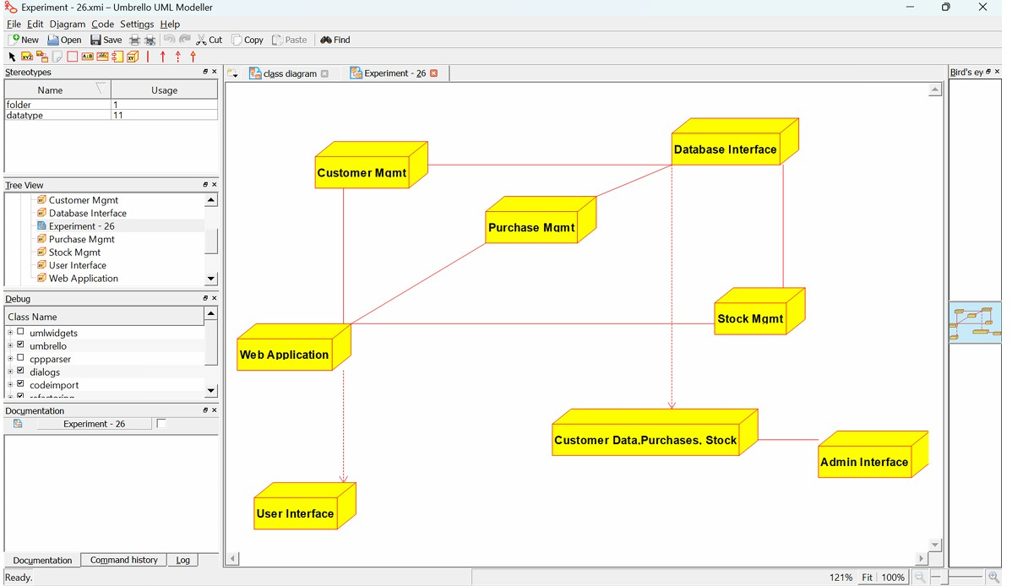

**RESULT:**

Thus the deployment diagram for the Passport Automation system has been designed, executed and output is verified.

# EXPERIMENT-27:Supermarket Management System

**AIM:**

To draw the deployment diagram for the Supermarket Management System

**SOFTWARE REQUIREMENTS:**

Umbrello UML modeller

## DEPLOYMENT DIAGRAM

A deployment diagram in the unified modeling language serves to model the physical deployment of artifacts on deployment targets. Deployment diagrams show "the allocation of artifacts to nodes according to the Deployments defined between them. It is represented by 3- dimentional box. Dependencies are represented by communication association.

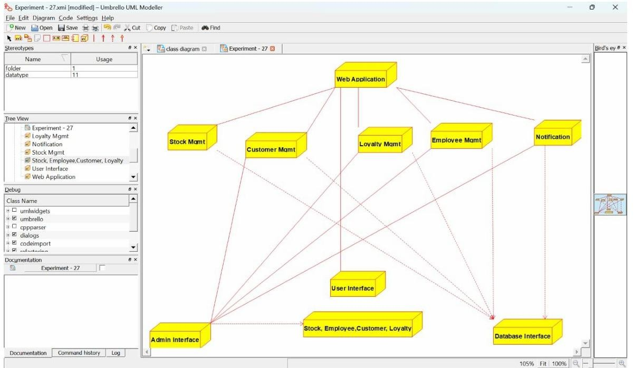

**RESULT:**

Thus the deployment diagram for the Supermarket Management System has been designed, executed and output is verified.

# Airplane Reservation System

To draw the deployment diagram for the Airplane Reservation System

**SOFTWARE REQUIREMENTS:**

Umbrello UML modeller

## DEPLOYMENT DIAGRAM

A deployment diagram in the unified modeling language serves to model the physical deployment of artifacts on deployment targets. Deployment diagrams show "the allocation of artifacts to nodes according to the Deployments defined between them. It is represented by 3- dimentional box. Dependencies are represented by communication association.

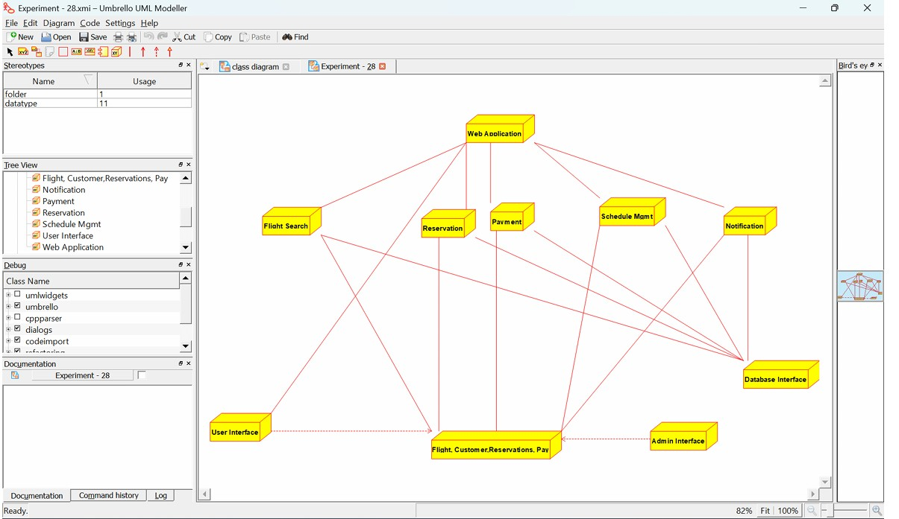

**RESULT:**

Thus the deployment diagram for the Airplane reservation system has been designed, executed and output is verified.

# Bus Ticket Reservation System

To draw the class diagram for the Bus ticket System

**SOFTWARE REQUIREMENTS:**

Umbrello UML modeller

**CLASS DIAGRAM:**

This diagram consists of the following classes, attributes and their operations..

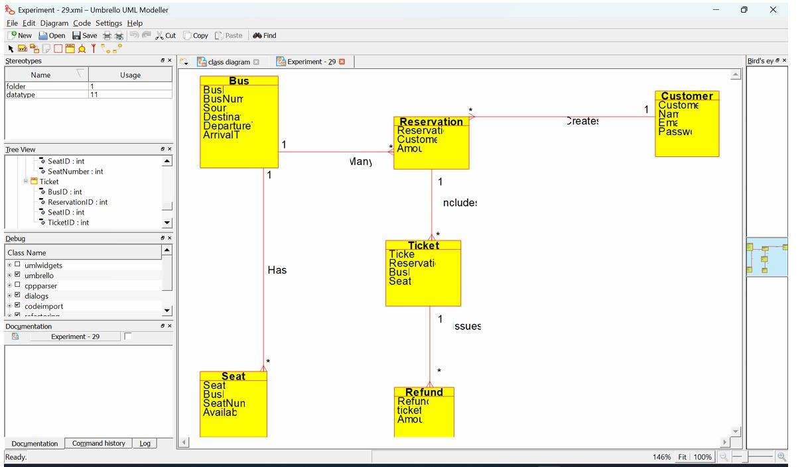

**RESULT:**

Thus the class diagram for the Bus ticket Reservation system has been designed, executed and output is verified.

# Train ticket Reservation System

To draw the class diagram for the Train Ticket Reservation System

**SOFTWARE REQUIREMENTS:**

Umbrello UML modeller

**CLASS DIAGRAM:**

This diagram consists of the following classes, attributes and their operations.

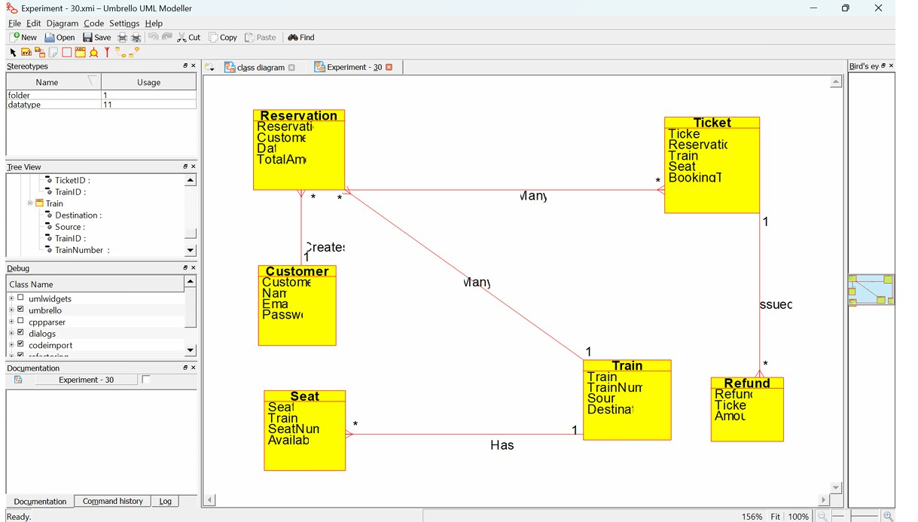

**RESULT:**

Thus the class diagram for the Train Ticket Reservation System has been designed, executed and output is verified.

**EXPERIMENT-31:Agriculture Loan Management**

**System**

**AIM:**

To draw the class diagram for the Agriculture Loan Management System

**SOFTWARE REQUIREMENTS:**

Umbrello UML modeller

**CLASS DIAGRAM**

A class is drawn as rectangle box with three compartments or components separated by horizontal lines. The top compartment holds the class name and middle compartment holds the attribute and bottom compartment holds list of operations.

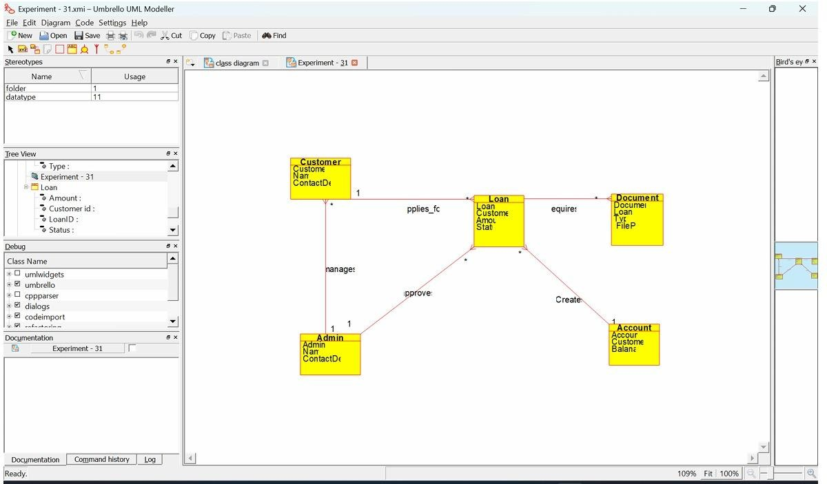

**RESULT:**

Thus the class diagram for the Agriculture Loan Management System has been designed, executed and output is verified.

**EXPERIMENT-32:Jewel Loan Management System.**

**AIM:**

To draw the class diagram for the Jewel Loan Management System.

**SOFTWARE REQUIREMENTS:**

Umbrello UML modeller

**CLASS DIAGRAM**

A class is drawn as rectangle box with three compartments or components separated by horizontal lines. The top compartment holds the class name and middle compartment holds the attribute and bottom compartment holds list of operations.

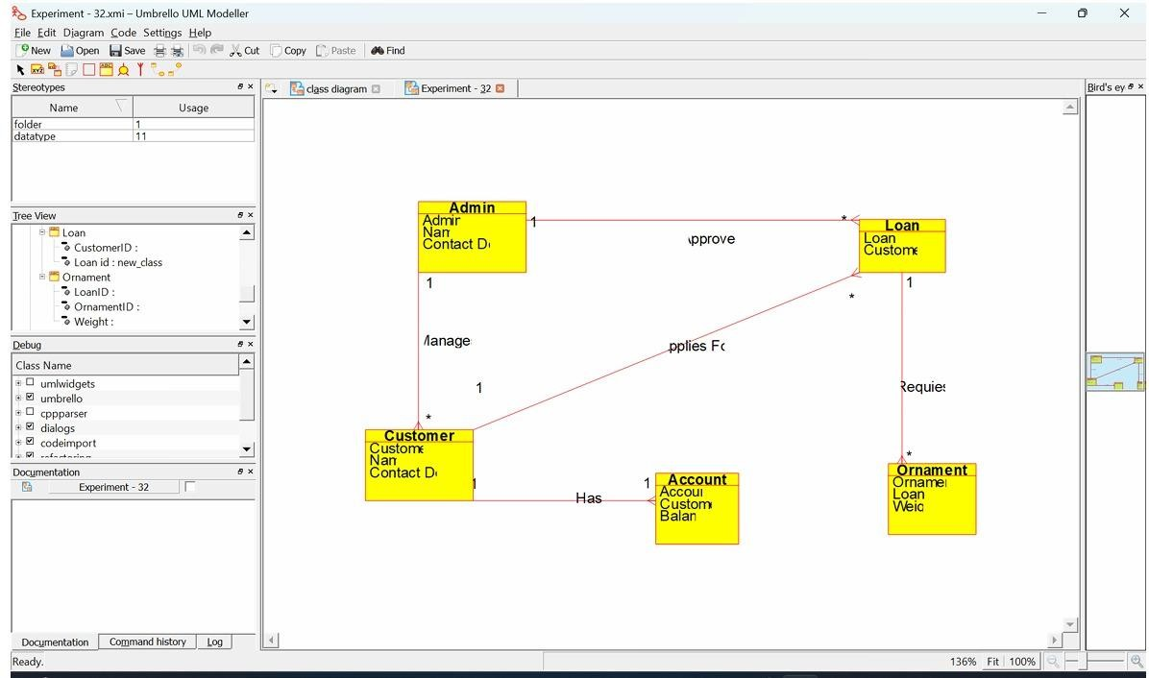

**RESULT:**

Thus the class diagram for the Jewel Loan Management System has been designed, executed and output is verified.

# EXPERIMENT-33:Personal Loan Management System

**AIM:**

To draw the component diagram for the Personal Loan Management System **SOFTWARE REQUIREMENTS:**

Umbrello UML modeller

**COMPONENT DIAGRAM**

The component diagram is represented by figure dependency and it is a graph of design of figure dependency. The component diagram's main purpose is to show the structural relationships between the components of systems. It is represented by boxed figure.

Dependencies are represented by communication association

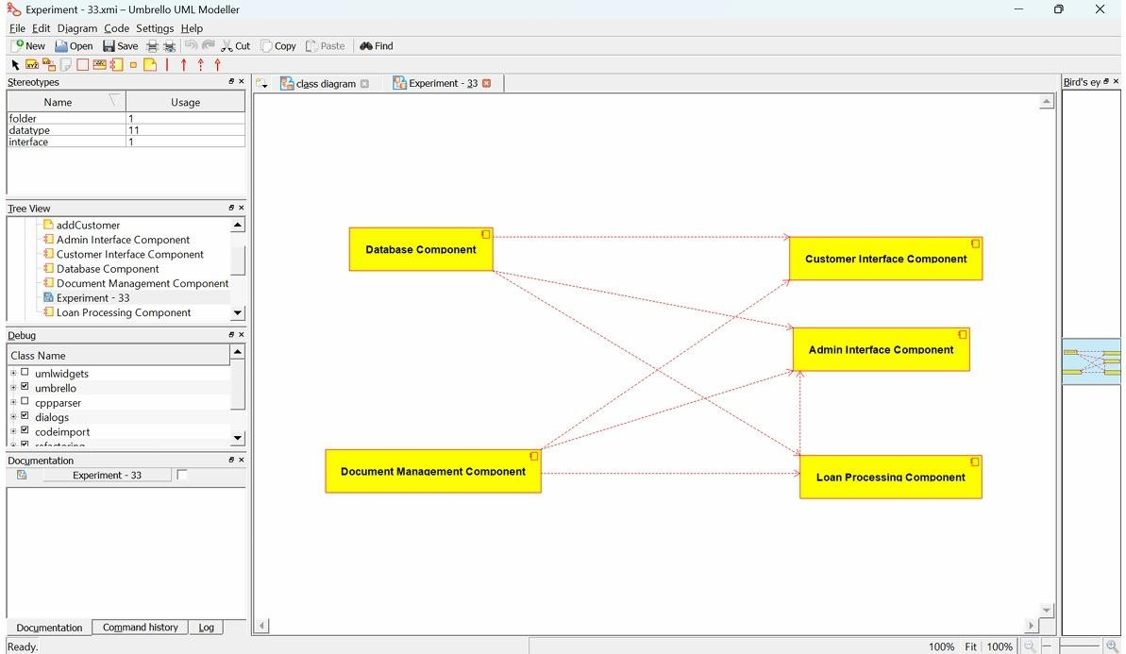

**RESULT:**

Thus the component diagram for the Personal Loan Management System has been designed, executed and output is verified.

# EXPERIMENT-34:Home Loan Management System

**AIM:**

To draw the component diagram for the Home Loan Management System **SOFTWARE REQUIREMENTS:**

Umbrello UML modeller

**COMPONENT DIAGRAM**

The component diagram is represented by figure dependency and it is a graph of design of figure dependency. The component diagram's main purpose is to show the structural relationships between the components of systems. It is represented by boxed figure.

Dependencies are represented by communication association

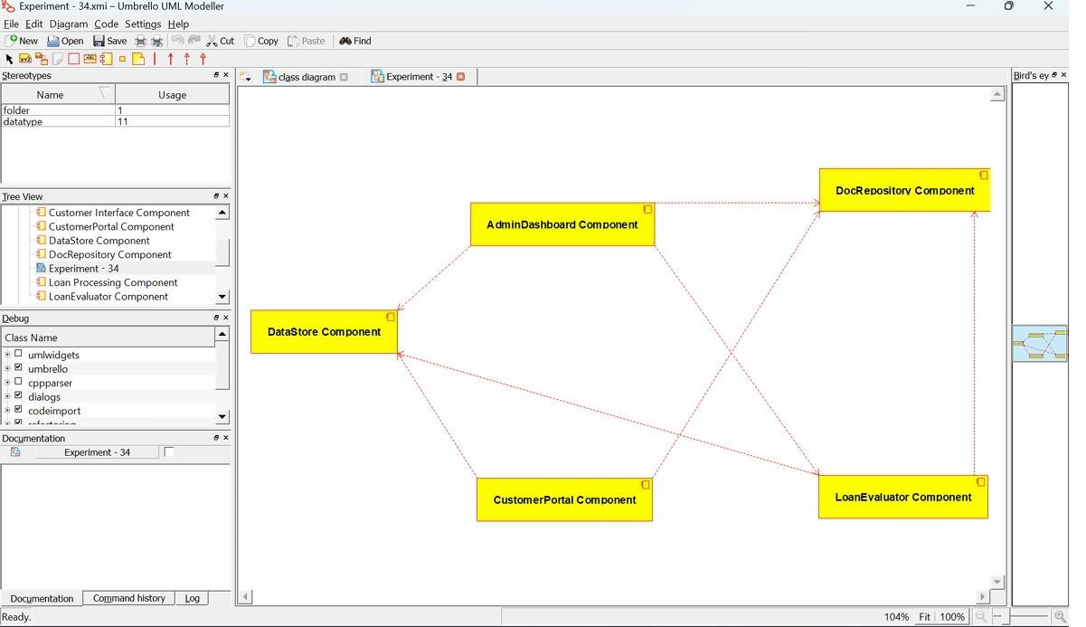

**RESULT:**

Thus the component diagram for the Home Loan Management System has been designed, executed and output is verified.

# EXPERIMENT-35: Land Registration System

**AIM:**

To draw the component diagram for the Land Registration System.

**SOFTWARE REQUIREMENTS:**

Umbrello UML modeller

**COMPONENT DIAGRAM**

The component diagram is represented by figure dependency and it is a graph of design of figure dependency. The component diagram's main purpose is to show the structural relationships between the components of systems. It is represented by boxed figure.

Dependencies are represented by communication association

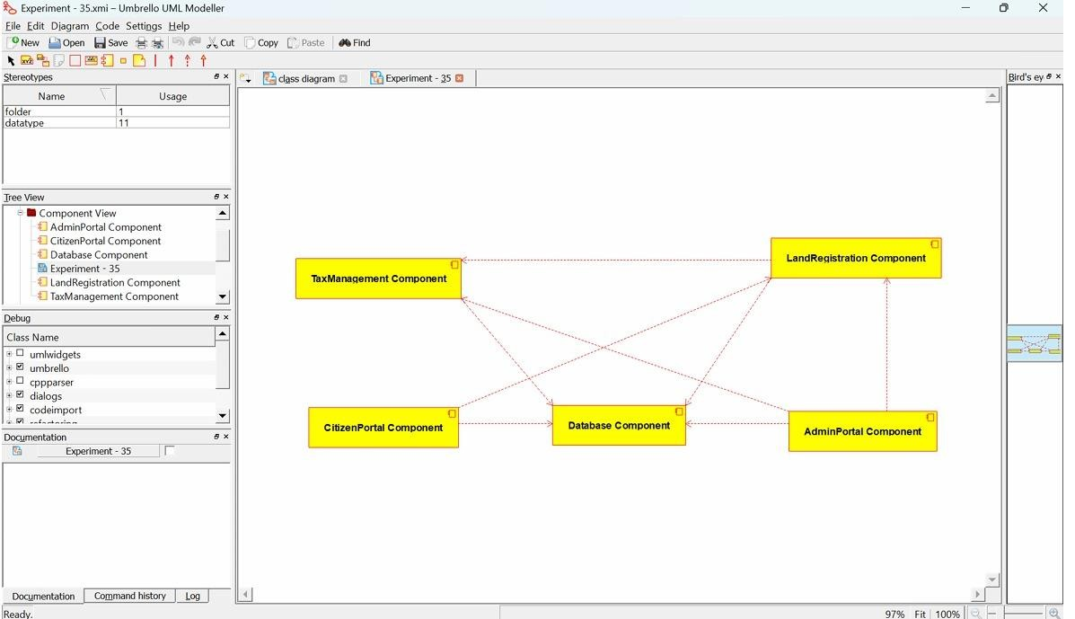

**RESULT:**

Thus the component diagram for the Land Registration System has been designed, executed and output is verified.

1. **Develop a system using UML for Car/Bike Vehicle Booking System. The system should support the renting of different automobiles by the customer. Each vehicle should have a unique access detail. The system should be able to send a notification whenever the reservation is approaching the pickup date, as well as when the vehicle is nearing the due date. The system should maintain a vehicle log to track all events related to the vehicles.**

**Aim:** The aim of this project is to develop a Car/Bike Vehicle Booking System using UML that allows customers to rent different types of automobiles efficiently. **Software used:** Umbrello **Use case diagram:**

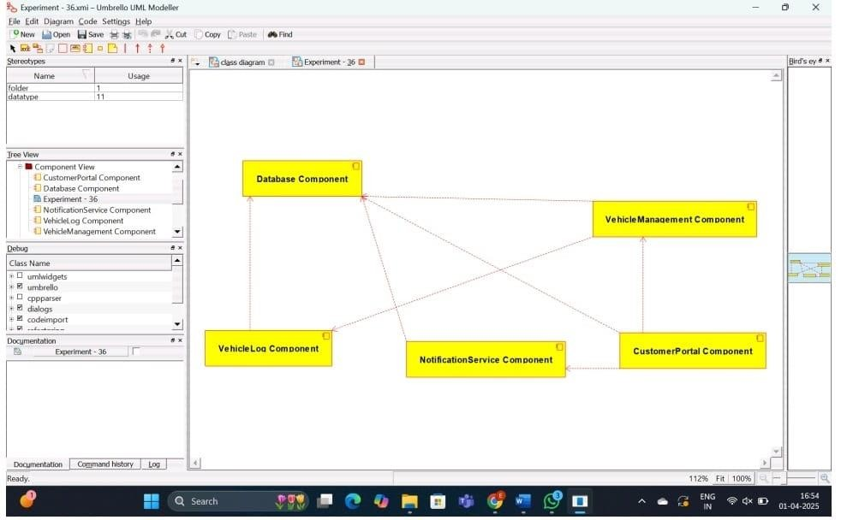

**Result:** Thus the project of implementing the Car/Bike Vehicle Booking System is created and the **implementation of the program in Java is successfully done**.

1. **Develop a system using UML for Doctor Appointment System. The central system should manage doctors’ availability and appointments for the given date. The patient can book the doctor’s appointment based on the doctor’s availability. When the booking is confirmed, it should be updated with the patient and doctor.**

**Aim:** To design a UML diagram for Doctor Appointment System using umbrello software and implement the program in java. **Software used:** Umbrello **Diagram:**

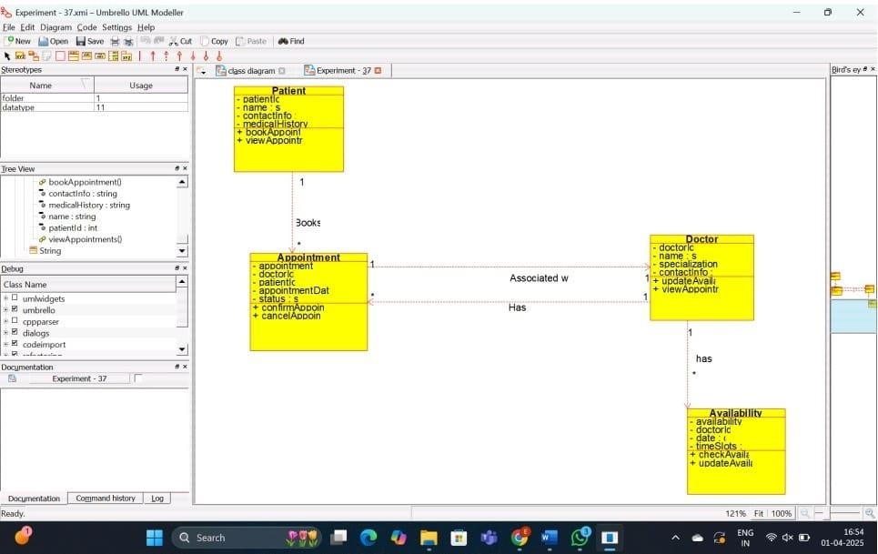

**Result:** Thus the project of implementing the Doctor Appointment System is created and the implementation of program in java is successfully done.

**38.Develop a system using UML for Salon/Beauty Parlour Reservation System. The central system should manage beauticians’ availability and appointments for the given date. The customer can book the beautician appointment based on availability. When the booking is confirmed, it should be updated for the patient and beautician.**

**Aim:** To design a UML diagram for Salon/Beauty Parlour Reservation System using umbrello software and implement the program in java. **Software used:** Umbrello **Daigram:**

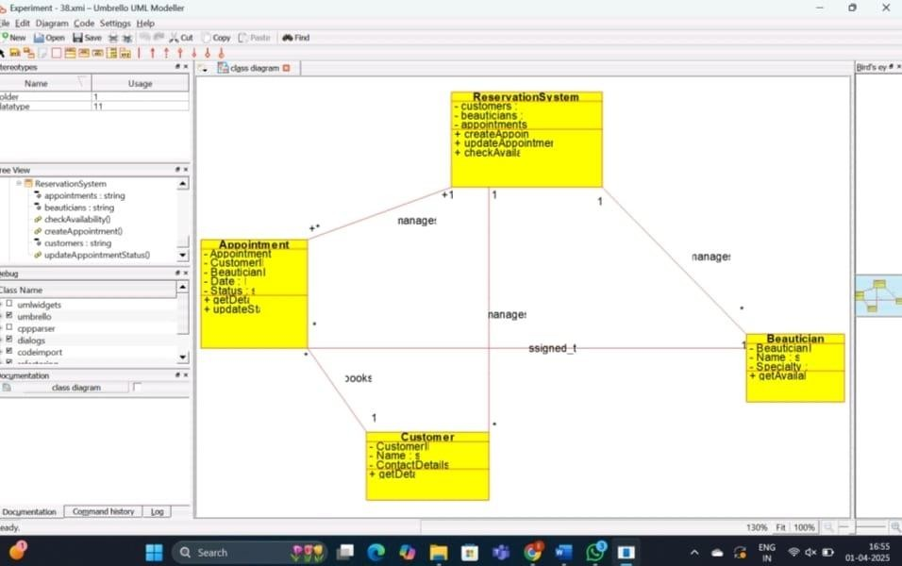

**Result:** Thus the project of implementing the Salon/Beauty Parlour Reservation System is created and the implementation of program in java is successfully done.

1. **Develop a system using UML for Gardener Booking System. The central system should manage the list of gardeners and their availability and appointments for the given date. The customer can book the gardener’s appointment based on availability. When the booking is confirmed, it should be updated for the gardener and beautician.**

**Aim:** To design a UML diagram for Gardener Booking System using umbrello software and implement the program in java.  **Software used:** Umbrello  **Diagram:**

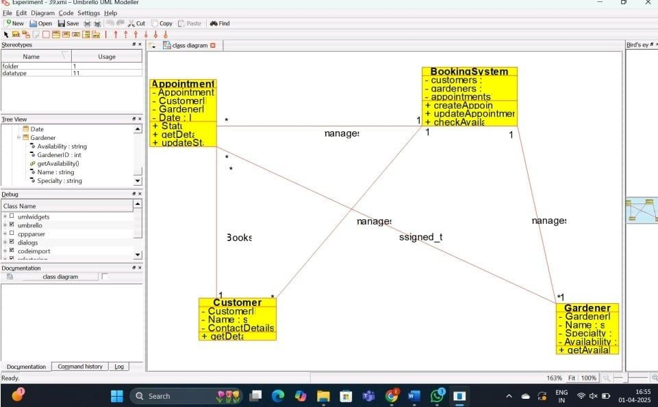

**Result:** Thus the project of implementing the Gardener Booking System is created and the implementation of program in java is successfully done.

1. **Develop a system using UML for HOME Tax Collection System. The system should generate the house tax for all the homes in the stipulated area it covers and the same should be sent to the owner of the home. The owners should be allowed to pay the tax online or offline. When the deadline for the bill is nearer, a reminder message should be sent to the owner. When the deadline is crossed, it should be intimated to the owner and the admin to take corresponding actions.**

**Aim:** To design a UML diagram for HOME Tax Collection System using umbrello software and implement the program in java.  **Software used:** Umbrello  **Diagram:**

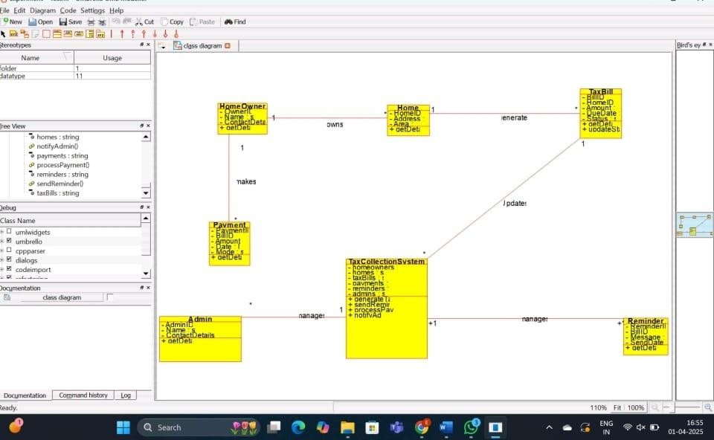

**Result:** Thus the project of implementing the HOME Tax Collection System is created and the implementation of program in java is successfully done